Officer of the Day (OOD) Guidance Notes (Issue 3)

OOD Equipment
- The OOD bag is kept in the top drawer of a filing cabinet in the Bosun’s store. It contains the OOD gate and hut key, club flag, radio, two timers, batteries, notebook, relevant forms for the race (sign-on sheet, race record sheet), and guidance notes.
- The OOD hut is located on top of the club and is accessed via stairs on the balcony. A key is needed for the gate leading to the hut (kept in the bag).

Course Setting
- The first job is to set the course. At CSC, this decision is taken after discussing with, and taking advice from, the more experienced sailors (especially if the OOD is relatively inexperienced).
- OOD needs to have course agreed approx. 30 minutes before the race start so that the Safety Boat crew know how many buoys will be needed and where buoys need to be laid.
- The course should be drawn on the board at the main entrance to the club, next to the Bosun’s store. Add the scheduled race start time, high water time, high water height, wind direction, wind speed, and the names of the OOD, Safety Boat skipper and crew on the smaller course information board.
- Generally sailing races are not started on a run with a following wind, but at CSC this may be done due to the characteristics of sailing at Clevedon where we are dependent on wind, sea state and tidal conditions. It is better not to set a course with a beat in front of the rocks, but again, it may be done due to conditions.

Sign-on Sheet
- The sign-on sheet is how sailors qualify to race, but it is also used as a record of who is on the water. If racers fail to sign-on, the OOD should disqualify them from the race.
- A new sign-up sheet should be attached the wall beside the course map. This sheet is used to collect information on the sailors who intend to race on the day - this includes name, class, sail number and their signature. This information is used for the race record sheet, so it must be collected before the race start.
- The OOD will need to call the Safety Boat for sailors missing from the sign-on sheet.
- There is also a sign-off box but this is not always used.

Pre-race Preparation
- Plug in the radio to the slots under the desk, and ensure it clicks into place. Switch on the radio and use channel P1. Use the ‘Squelch’ dial to just silence any white noise.
- Raise the club spinnaker.
- Put batteries in both timers and check they are operating correctly. They should be set to the ‘Cumulative’ setting rather than ‘Lap’. Two timers are used so that if one goes wrong, or is accidently reset, there is a spare.
- Open the window and align the two poles in the start-line frame to the distance mark. It is likely the distance buoy will move during the race, but there is no need to adjust the start-line frame.
- Check that all the race boards are down and that the hooter works.

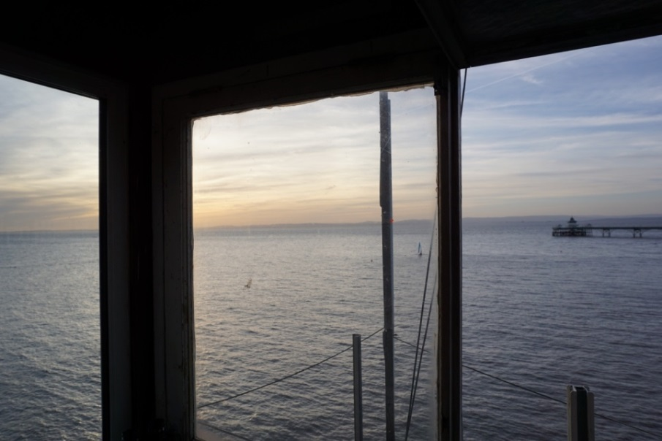
Figure 1 - Frame used to mark Start Line
- Call Safety Boat for a radio check. The radio should be on channel P1 (this is equivalent to channel 37 on the hand-held radios. Some radio protocol is given below.
- The Safety Boat will drop the sea-mark(s) as per the set course and confirm via the radio.
- Give the sailors chance to launch and get themselves ready for the race start. If there are any lagging behind, you may need to ask the Safety Boat to check whether they are racing or not. There is limited time for racing, so the race needs to be started as near to the scheduled start as possible.

Radio Protocol
- The OOD hut call sign is ‘Peterson’.
- ‘Over’ is used at the end of a statement to indicate you have finished talking and are awaiting a response.
- ‘Out’ is used at the end of a statement to indicate you have finished the conversation and are not awaiting a reply.

Hail Safety Boat (Valiant) | ‘Valiant, Valiant, (this is) Peterson, over‘
Hail Safety Boat (Sea Rider) | ‘Sea Rider, Sea Rider, (this is) Peterson, over‘
Responding to a hail (from Valiant) | ‘Valiant, (this is) Peterson, over.’
Finishing a conversation (with Sea Rider) | ‘Sea Rider, (this is) Peterson, I’m leaving the hut; out.’

- Valiant has a red tube and a white hull
- SeaRider is the older small RIB, grey with an orange hull.
- Zodiac is the new small RIB with a grey hull.

VHF Base Station Instructions (Chris Cooper)
These instructions should be used with Figures 7 & 8 at the end of the OOD Guidance Notes.
- Ensure Power switch on wall marked Horn / Radio is Off
- Connect aerial and power leads
- Place on wooden support with the bungee cord that stops it coming off
- Turn on power at wall switch
- Turn Radio on using volume switch
- Unit advises that DSC is not available and middle button needs to select OK
- Channel ‘M’ should be selected
  - If not, use up and down Channel selection buttons until it is
  - Channel ‘M’ will communicate with 37A on Hand Held units.
- Adjust Squelch if required.
- Use unit in ‘LO’ mode for normal use and ‘HI’ mode when needing to broadcast over longer distance

NOTE:
If you need to contact the Coastguard, then use your mobile phone rather than via the VHF on Channel 16
This is because the Coastguard will require you to remain on CH16 meaning that you can no longer communicate with your Safety Team on Channel M / 37A

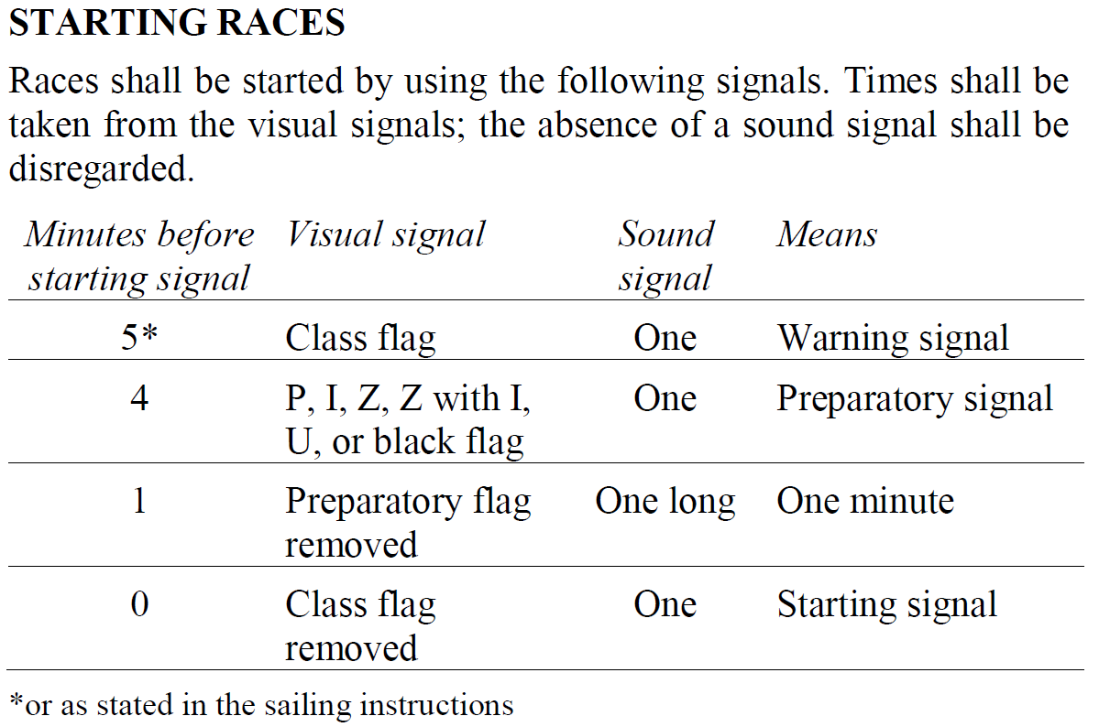
Race Start Sequence
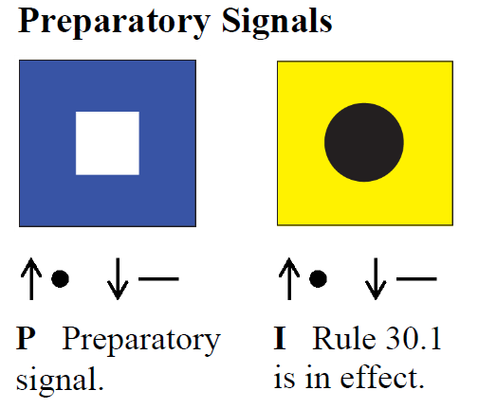
Figure 2 - Official ISAF Race Start rules

Figure 3 - Official ISAF Race Start flags with sound signals

Time to Start (Mins) | Hooter | Flag (Board)
5 | Sound Once | Raise R Flag (yellow cross on red square)
4 | Sound Once | Raise P Flag (white square on blue square)
1 | Sound Once Long | Lower P Flag
0 (Start) | Sound Once | Lower R Flag
- At Clevedon, we use the R and P flags shown in Figure 4, with the R Flag in place of the Class flag. The start sequence is;
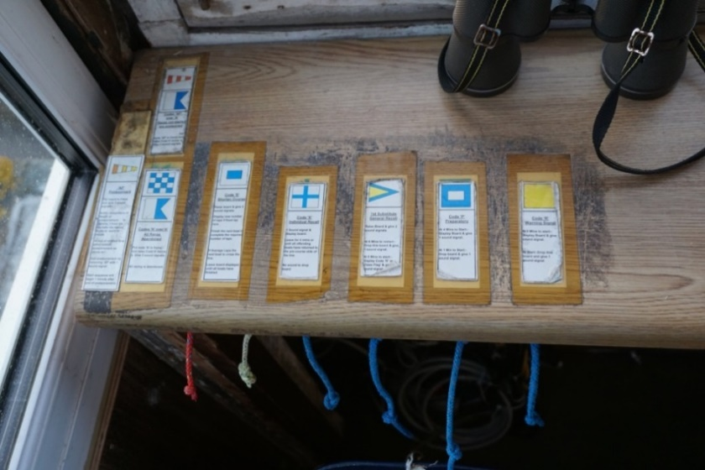
Figure 4 - Flag Pull Cords

- Use the clock, your watch, or start the timers to mark the start of the 5-minute countdown and/or your wristwatch or mobile phone as timekeeping backup. Note, if you use the timers you will need to subtract the time from the final race times.
- The boards for each step of the start sequence are labelled in the OOD hut
- At the end of the final minute countdown, you need to press the green start buttons on BOTH timers, sound the horn, and watch the boats on the start line (all at once!)
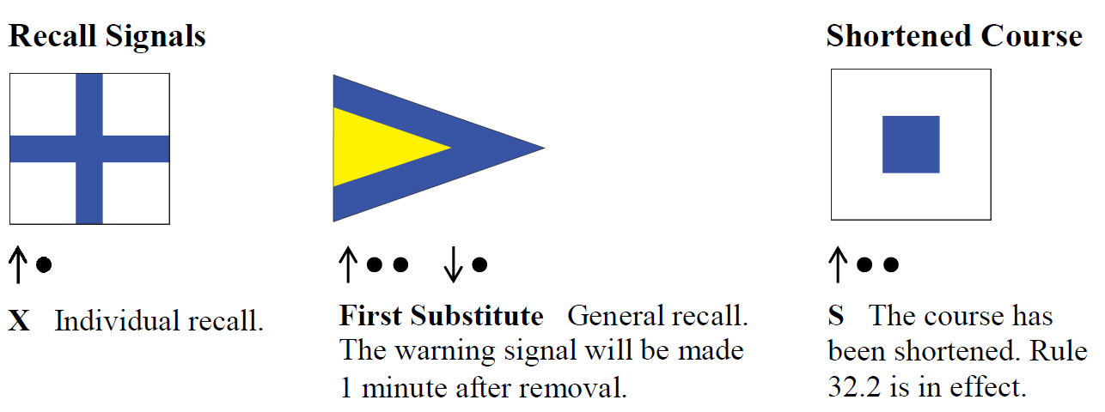
- Watch for boats creeping over the line by looking along the transit line made by the two poles on the OOD hut and the distance mark. You may need to recall individual boats, or recall the whole race if many boats are over the line.
Figure 5 - Official ISAF Race Recall and Shortened Course flags and sound signals

- Individual Recall
- If one or two boats are over the line, the need to sound one hoot and raise the board (see Figure 5, blue cross on a white background)
  - Notify the Safety Boat, but they do not tell the sailors
  - The sailors must take their own action to go back over the start line, the OOD does not tell them
  - Board is dropped after 4 minutes, but no sound signal
  - Failure to return over the start line means they are disqualified
- The rest of the fleet race normally
- General Recall
- If 3 or more boats are over the line, this is a General Recall and the race is restarted
  - Sound two hoots and raise board (see Figure 5, yellow triangle in blue triangle)
  - When fleet ready to be restarted, sound 1 hoot, lower the General Recall board
  - The normal start sequence should be started 1 minute later with the R flag

Monitoring the Race
- Keep watching the boats!
- Keep in touch with the Safety Boat especially in deteriorating weather conditions or when dropping wind may mean that boats may be carried on the ebbing tide.
  - Race may need to be shortened to avoid too many boats needing to be towed.
- For each boat the lap time should be noted. The timers have a (red) button that allows the time to be frozen on the display while it continues to time in the background. A second button push restores the real time. Alternatively, if the boats are not too close together, you might just note the time as they pass the line.
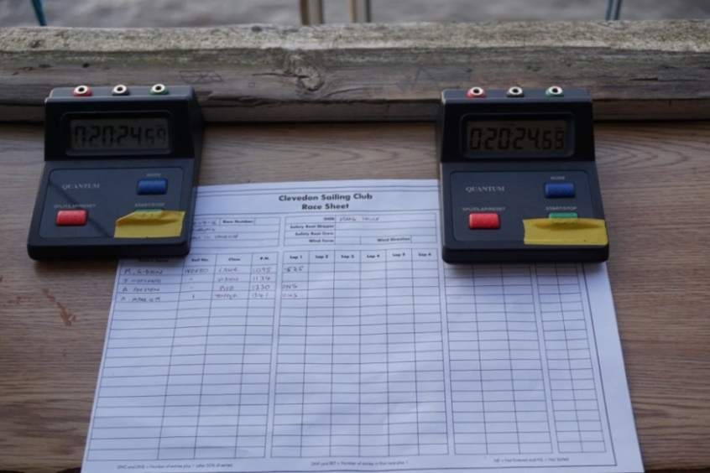
Figure 6 - Dual timers and Race Sheet

- The race sheets can be pre-filled with information ready for the race. Fill in each lap time for each boat. Note, different boats will complete a different number of laps, depending on how the race is finished (see below).

Finishing the Race
- Generally, aim for a race length of 45-60mins per race.
- Select the boat on which you will finish the race – this is often a boat at the back or where there is a bigger gap in the fleet. The shortened course must be in whole laps. The S-board, (see Figure 5, blue square on a white background) which signifies a shortened race, is raised before the chosen boat passes the buoy before the finish line. Sound 2 hoots when the board is raised. The S-board is used because the races are often less than 60mins which is the threshold for a short race.
- Talk to the Safety Boat to agree and confirm when the race will finish. They may be able to offer advice on conditions, and whether it is a good point to finish.
- Sound the hooter once when the boat you’re finishing the race on crosses the line. Note the time. If you have a lot of boats finishing at once, use alternate timers for each boat in sequence and have some scrap paper to take quick notes of times to be added to race sheet later.
- Then for each successive boat repeat (i.e., sound hooter and note finish time).
- Once all boats are across the finish line, give them 5 minutes, or so, and then commence the second race.

After the Last Race
- Confirm with the Safety Boat that the last race has finished.
- Stay in the OOD hut until the last boat is on the slip.
- Lower all the race boards, lower the flag, shut the window.
- Radio the Safety Boat to confirm when you are leaving the hut.
- Switch off the radio, remove it. Collect all the equipment in the bag, and leave the hut, turning off the lights, and locking the door.

Race Sheet Calculations
- Guidance on the calculations is given on a sheet in the OOD bag.
- Convert the lap times into ‘Overall Time’ in seconds (add all the lap times together).
- Calculate the ‘Corrected Time’ using the ‘Portsmouth Yardstick Number (PN)’ handicaps for each boat. Corrected Time = (Overall time x 1000) / PN.
- Calculate the ‘Average Lap Time’, not all boats will sail the same number of laps
- Note, for Lasers, if the sailor always uses a Radial, or 4.7 rig, then the specific handicap can be applied. If the sailor normally sails with a standard rig, but chooses to use a radial or 4.7, on the day, the standard rig handicap is still used for that series.
- Indicate the final positions for each race.
- Note you can write RET if boats retire from the race without finishing.
- Add the results to the back-up record book which is kept in the OOD bag. Note, use the plastic sheet to prevent ‘copies’ being made throughout the pages!
- If you have a camera phone, photograph the results and send in an e-mail to maelliott@virginmedia.com. If you notice a problem; dried pens, flat batteries, only a few race sheets or signing on sheets etc please include this in the e-mail.
- Pin the results on the club Sailing notice board, near the bar for the sailors to view.

Figure 7 - VHF Base Station Setup

Figure 8 - Unit Use Instructions

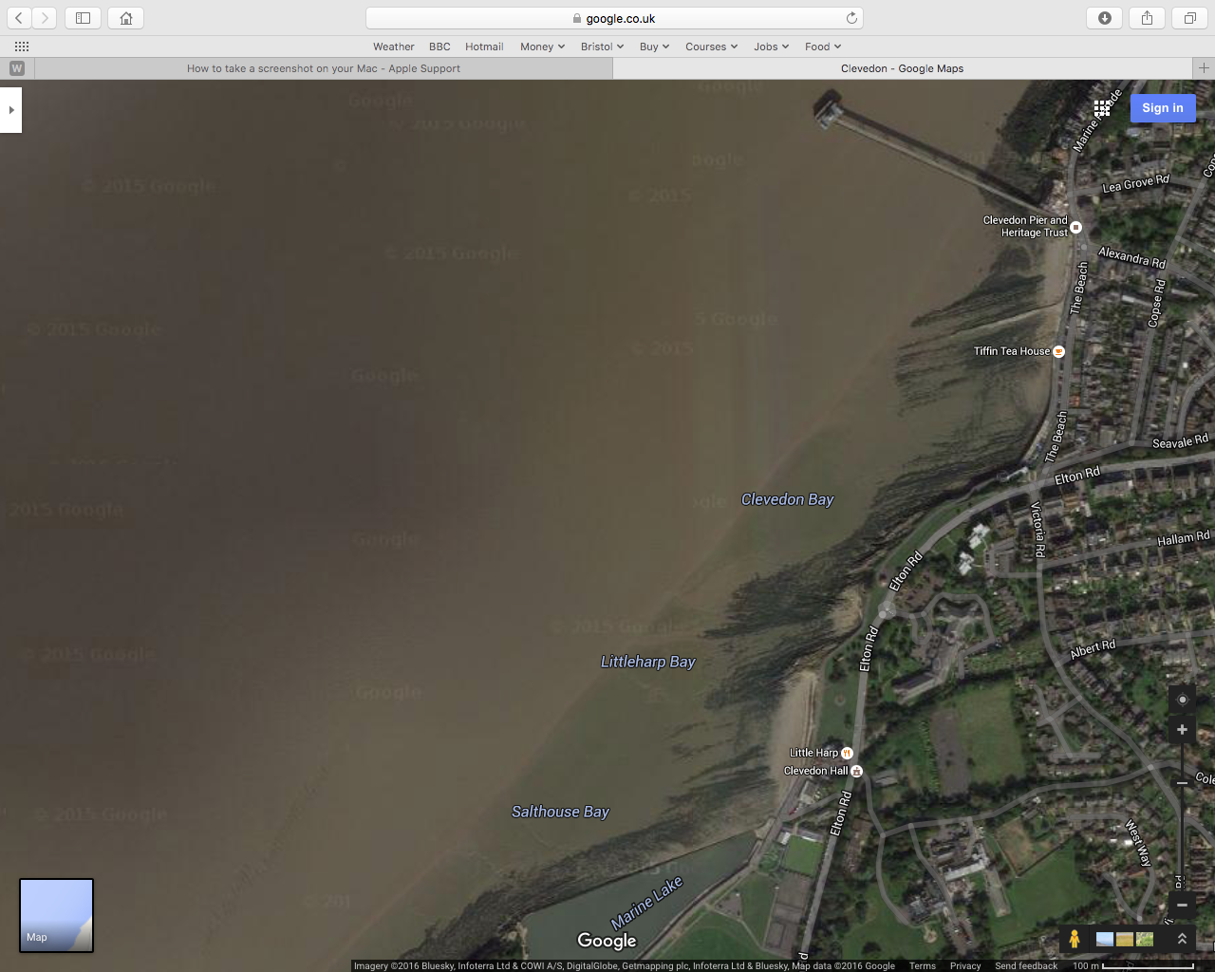
N
South Westerly
Sea Mark
Pier Mark
Distance
Mark
Wain’s Hill
Mark
Bandstand
Mark

